ASSIGNMENT-1

NAME :ANUKEERTHANA S

CIRCUIT IMAGE:

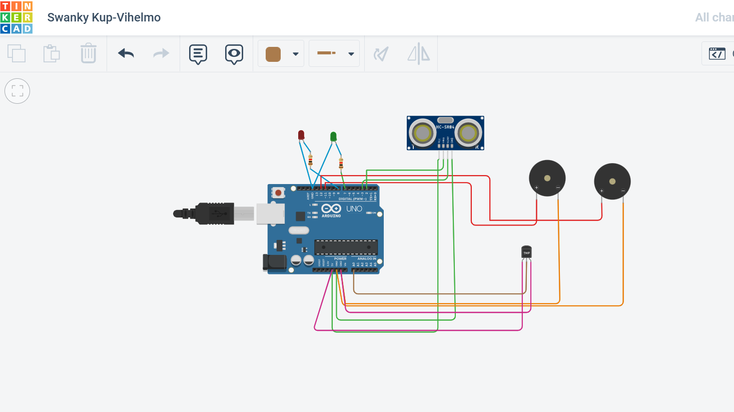

CODE FOR SIMULATION:

int t=2;

int e=3;

void setup()

{

Serial.begin(9600);

pinMode(t,OUTPUT);

pinMode(e,INPUT);

pinMode(12,OUTPUT);

}

void loop()

{

//FOR ULTRASONIC SENSOR//

digitalWrite(t,LOW);

digitalWrite(t,HIGH);

delayMicroseconds(10);

digitalWrite(t,LOW);

float dur=pulseIn(e,HIGH);

float dis=(dur\*0.0343)/2;

Serial.print("Distance is: ");

Serial.println(dis);

//FOR LED ON//

if(dis>=100)

{

digitalWrite(87,HIGH);

digitalWrite(7,HIGH);

}

//FOR BUZZER - ULTRASONIC SENSOR//

if(dis>=100)

{

for(int i=0;i<=30000;i=i+10)

{

tone(12,i);

delay(1000);

noTone(12);

delay(1000);

}

}

//FOR TEMPERATE SENSOR//

double a = analogRead(A0);

double t=(((a/1024)\*5)-0.5)\*100;

Serial.print("Temp Value: ");

Serial.println(t);

delay(1000);

//FOR LED ON//

if(t>=100)

{

digitalWrite(8,HIGH);

digitalWrite(7,HIGH);

}

//FOR BUZZER - TEMPERATE SENSOR//

if(if t>=100)

{

for(int i=0;i<=30000;i=i+10)

{

tone(12,i);

delay(1000);

noTone(112);

delay(1000);

}

}

//FOR LED OFF//

if(t<100)

{

digitalWrite(8,LOW);

digitalWrite(7,LOW);

}

}